**Jaypee Institute of Information Technology**

**Database Systems & Web (15B11CI312)**

**Tutorial 9(Relational Algebra)**

**Company Database**

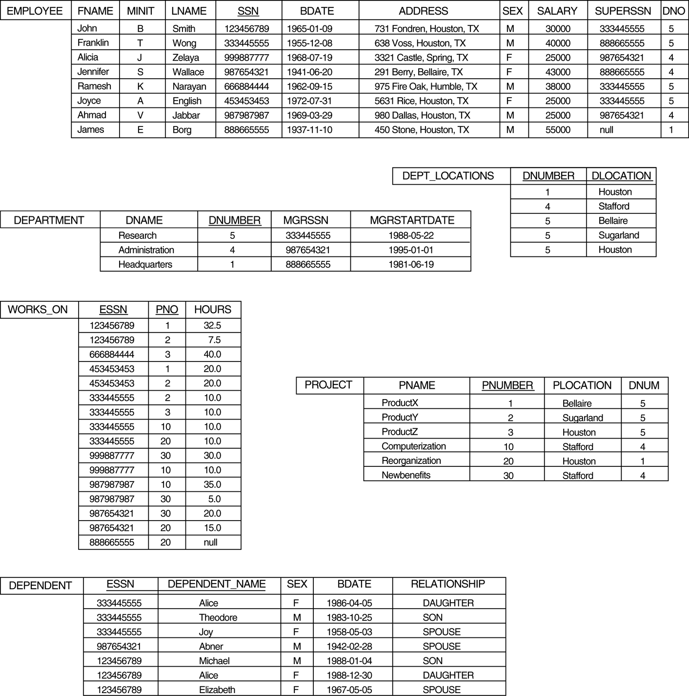

Q1: Retrieve the name and address of all employees who work for the ‘Research’ department.

Q2: For every project located in ‘Stafford’, list the project number, the controlling department number, and the department manager’s last name, address, and birthrate

Q3: Find the names of employees who work on all the projects controlled by department number 5.

Q4: Make a list of project numbers for projects that involve an employee whose last name is ‘Smith’, either as a worker or as a manager of the department that controls the project.

Q5: List the names of all employees with two or more dependents.

Q6: Retrieve the names of employees who have no dependents.

Q7: List the names of managers who have at least one dependent.